**AIT-524, Class 11, Practice Problems**

**Tanmoy Chowdhury, G01025893**

**Practice Problems: Basic DML**

**Questions:**

* **Problem 1: Find two related tables in the JustLee Books database and identify a common field between the two tables. Select four-five columns that you would like to display in the output (do not use SELECT *). Write a SQL code to join the tables using the WHERE statement. Make sure to include qualifiers for columns that appear in both tables. Since only two tables are joined, make sure to include one join condition in the WHERE statement. Explain what the query is intended to do in a complete, coherent sentence with no SQL terminology.**

**Answer:**

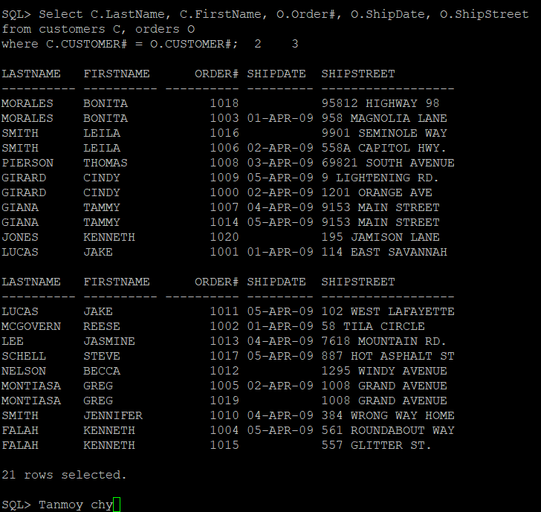

* **Problem 2: Repeat problem 1 but remove the WHERE statement. What happened? Why?**

**Answer:**

Here 420 rows have been selected. So I am not putting the full screenshot. I put the first and last portion of the output of this problem. As we are not putting the conditions so it is considering all rows.

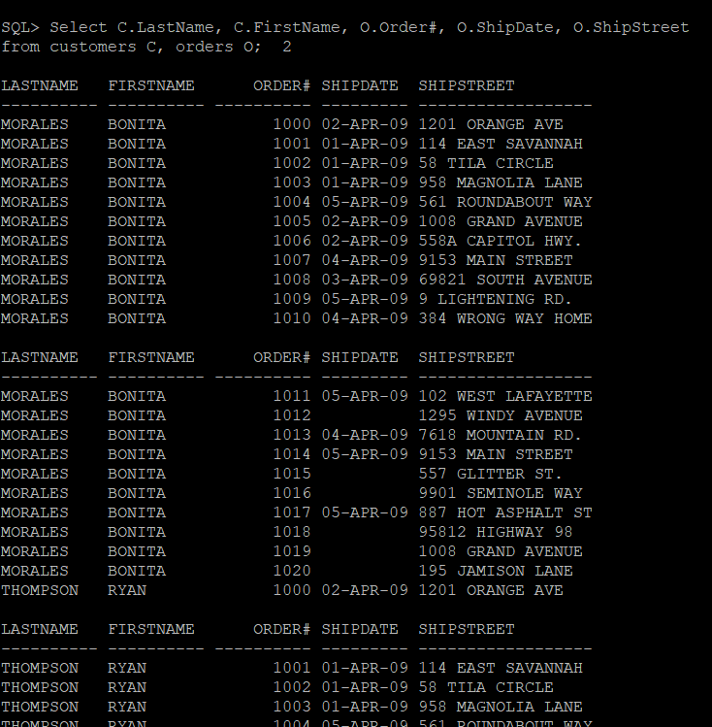

.

.

.

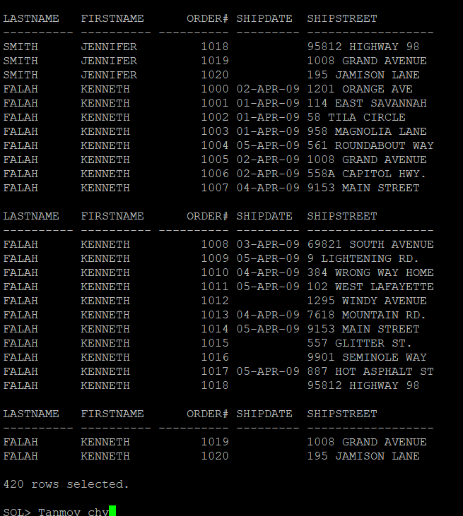

* **Problem 3: Write an SQL query to join three related tables using JOIN … ON in the JustLee Books. Select four-five columns that you would like to display in the output (do not use SELECT *). Include one condition with a special comparison operator. Explain what the query is intended to do in a complete, coherent sentence with no SQL terminology.**

**Answer:**

This query shows the Books’ ISBN, Title and Cost along with Authors’ first and last name.

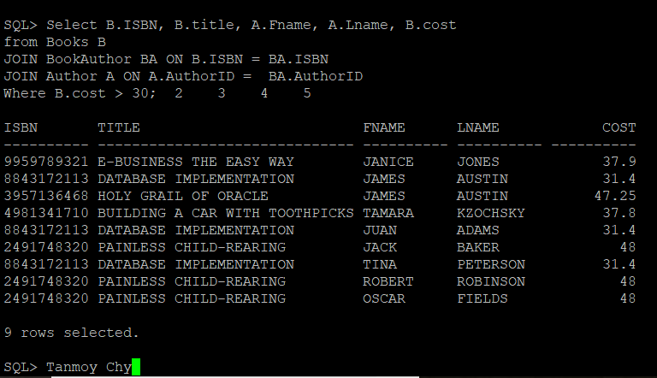

* **Problem 4: Write an SQL query to join three related tables using JOIN … USING in the JustLee Books. Select four-five columns that you would like to display in the output (do not use SELECT *). Include one condition with a special comparison operator and a logical operator. Do not use the same set of tables as before. Explain what the query is intended to do in a complete, coherent sentence with no SQL terminology.**

**Answer:**

Basically, this query tries to find out the quantity of the order item where ship cost is less than 5 but the paid for each is more than 30.

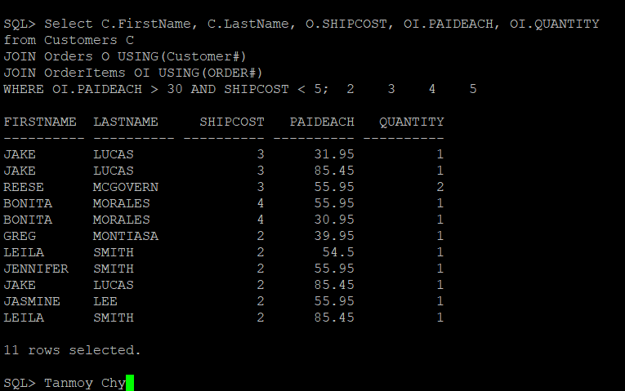

* **Problem 5: Write an SQL query to join two tables using JOIN…ON and JOIN…USING (use SELECT *). Did you receive the same output? Why?**

**Answer:**

Customer# has been appeared twice in case of ‘JOIN…ON’

**By JOIN…ON**

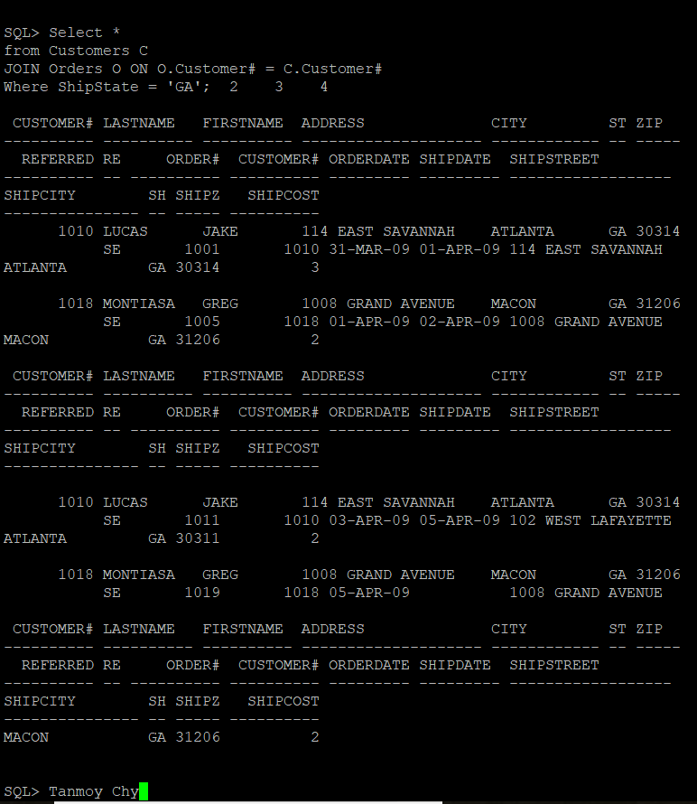

**By JOIN….USING**

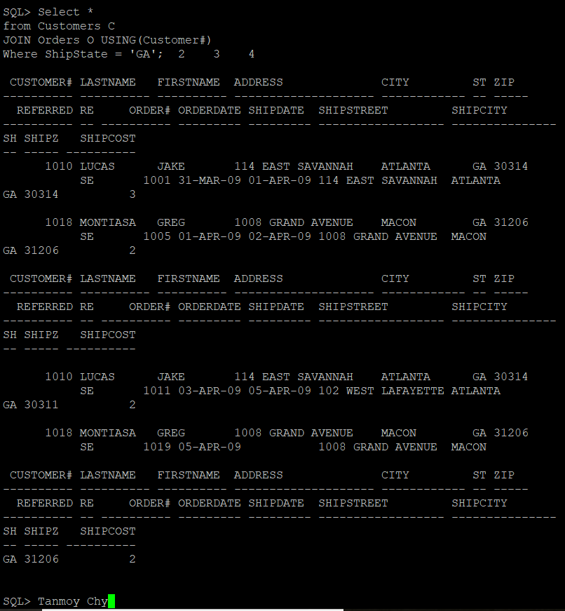

* **Problem 6: Write an SQL that lists customer’s last name and first name if he/she does not have the same address and shipping address and whose orders include books that have letter “a“ in the title. In addition, consider only the following authors: Peterson, Adams, and Austin. Explain why customers' names appear multiple times.**

**Answer:**

Customers’ name appear several times as they bought books of different writers.

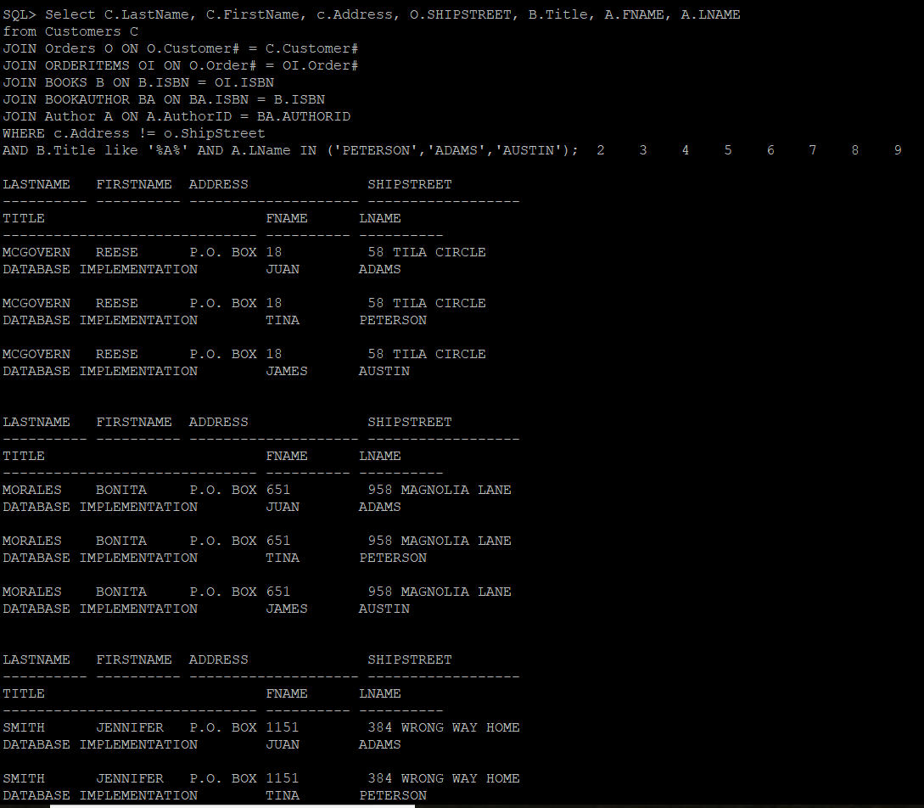

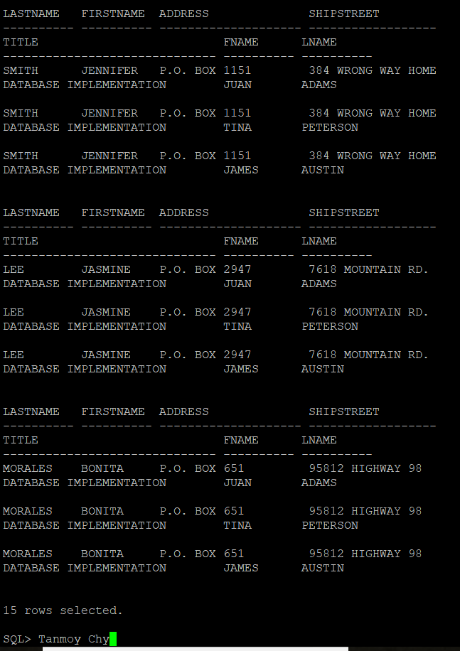

* **Problem 7: Write an SQL query to create a list of employees and their managers. Use columns’ aliases to clearly identify mangers and employees in the output. Before writing the solution, solve the problem on the whiteboard (show how you link columns to create this kind of join), take a picture and submit it too as part of your solution.**

**Answer:**

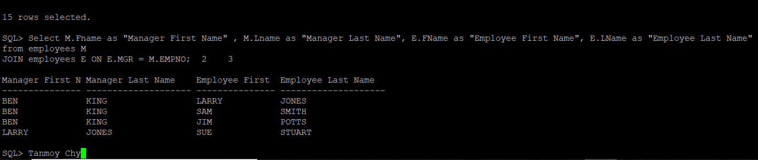

* **Problem 8: Modify Problem 7 to list all customers along with those who referred them (if any).**

**Answer:**

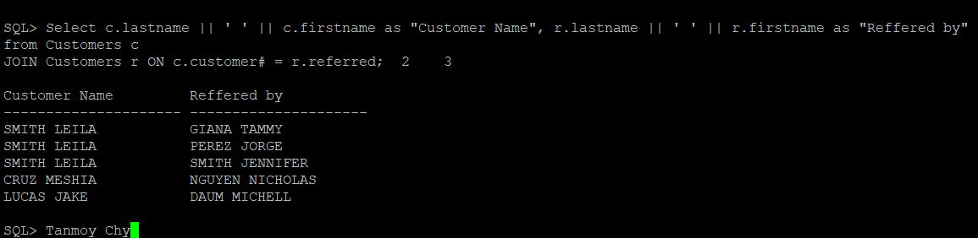

* **Problem 9: Write an SQL query to display a list of books in the BOOKS table. If a book has been ordered by a customer, also list the corresponding order number and the state in which the customer resides.**

**Answer:**

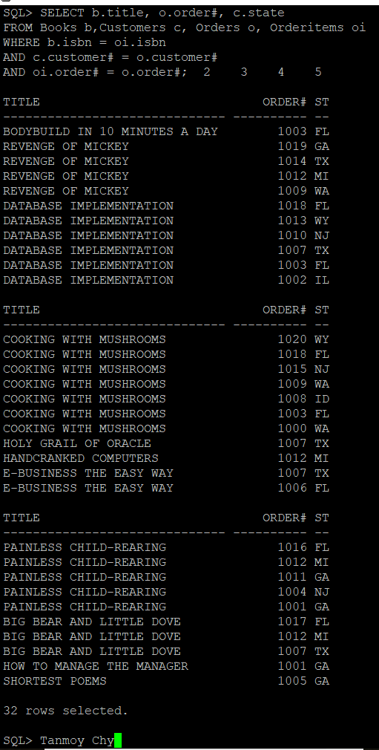

* **Problem 10: Use set operators UNION, UNION ALL, INTERSECT, and MINUS to combine the results of two queries. Explain what queries are intended to do in complete, coherent sentences with no SQL terminology.**

**Answer:**

I applied these 4 operators on the with discount and without discount. UNION shows only 24 results. There is no duplicate. But UNION ALL considered all and shows the duplicate results also. That’s why it becomes 32 rows. As there is no common so INTERSECT shows no rows and for MINUS it is showing the rows of only books with discount. As in that portion no book is there with discount. So, ultimately the number is same as like book without discount. The screenshots are as follows:

For UNION:

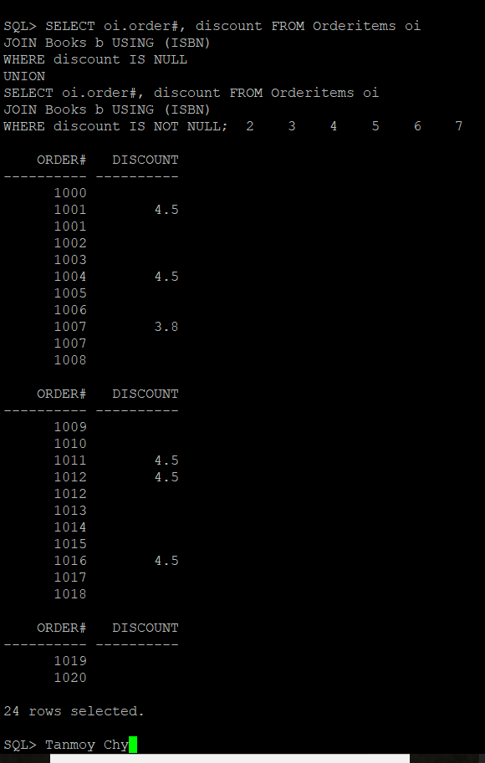

For the UNION ALL:

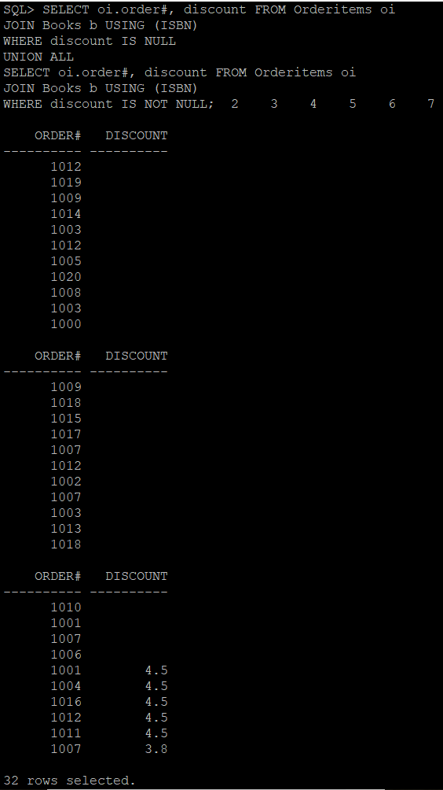

For INTERSECT

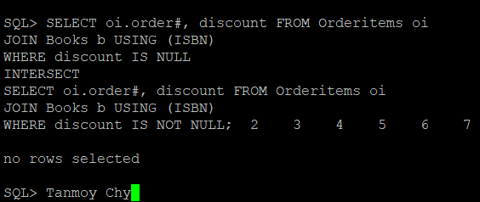

For MINUS

